KUNM Generation Listen
  - 2016-2017
Generation Listen is an NPR initiative designed to connect millennial students with their communities, their local public radio stations, and with each other.
KUNM-FM
Oñate Hall 3rd floor, 303 Girard Blvd NE, Albuquerque, NM 87106
Tel (505) 277-4806
KUNM.org

KUNM Generation Listen was founded to help create more student participation at KUNM-FM, The University of New Mexico’s public radio station. KUNM Generation Listen's mission is to connect students to their local public radio station, their community, and to each other. We do this by hosting meet-ups and public forums where we gather bright young minds for attentive listening and critical discussion. In addition, we have collaborated with other departments at UNM to promote campus events on social media as well as host Speaker Series events. The idea is to reassert the substantial importance of public radio, and how students can best use this resource. We have been in existence since June of 2015, and our most recent outreach efforts include co-hosting a speaker series event with The School of Public Administration on topics such as local governance of water, providing tours of the station, hosting tabling sessions at the SUB and providing a creative outlet for students to produce podcasts.
One of our main accomplishments of the past year was meeting the goal set by the president last year to get more people to attend our meetings and to have more interaction with the community of UNM and the rest of the Albuquerque community that are intrigued by radio and by what public radio has to offer. We have 10 regularly attending members of our podcasting team, and well over 30 different people have attended tours and meet ups. We offered 9 meetings, 16 podcast studio sessions, two live tweet events, and produced 12 episodes of the Breaking Math Podcast. Social media grows more successful as efforts are continued. The goal for this year is to provide a better hand-off of the student organization to the next president, participate in more fundraising events, and to produce more podcasts.
KUNM Generation Listen provides an avenue for the student voice to be heard on KUNM in music, news, and culture; other than the traditional requirement of volunteering as a host at the station. This is because there are only 24 hours of available programming in a day, and students provide other valuable resources to the station than volunteering to host a show. KUNM Generation Listen is offering a service that no other student group on campus is offering, and that is an ability to connect with KUNM and public radio. Not only is this student organization an avenue for people who already love public radio to come out and participate in radio, it is also a great way to introduce non-listeners to the unique news coverage of public radio and potentially increase the listenership of the whole medium. KUNM Generation Listen is one small step towards saving public radio.

Jalila Arthur  President |  | Seth Brewer  Vice-President |  |  | Gabe Hesch  Content Producer
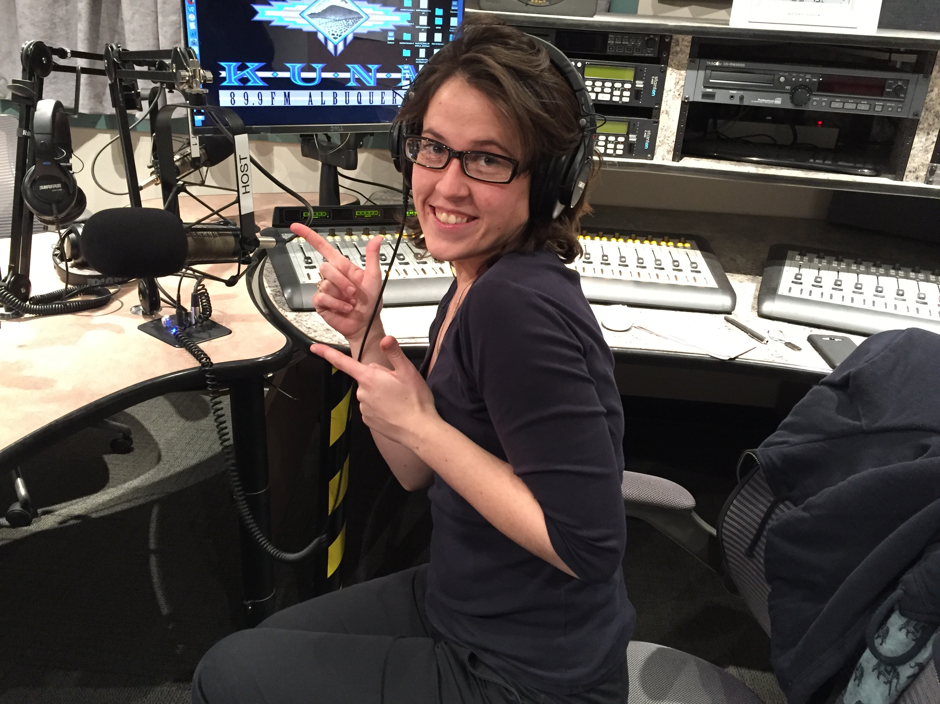 |  | 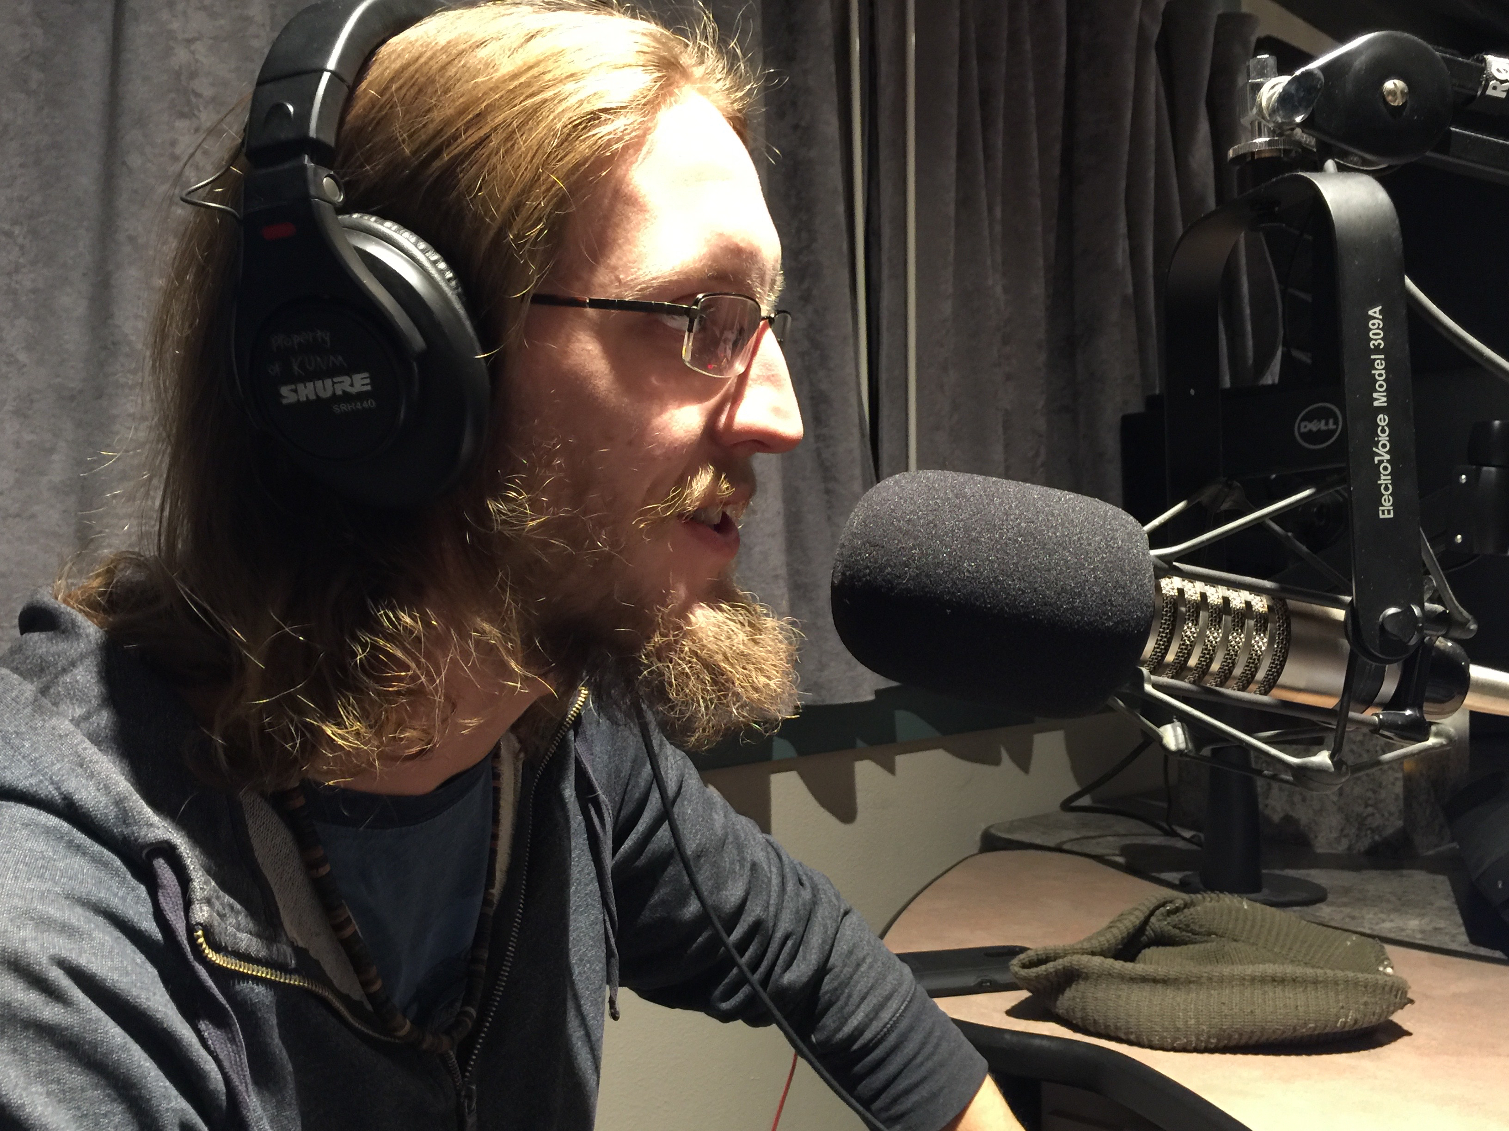 |  |  | 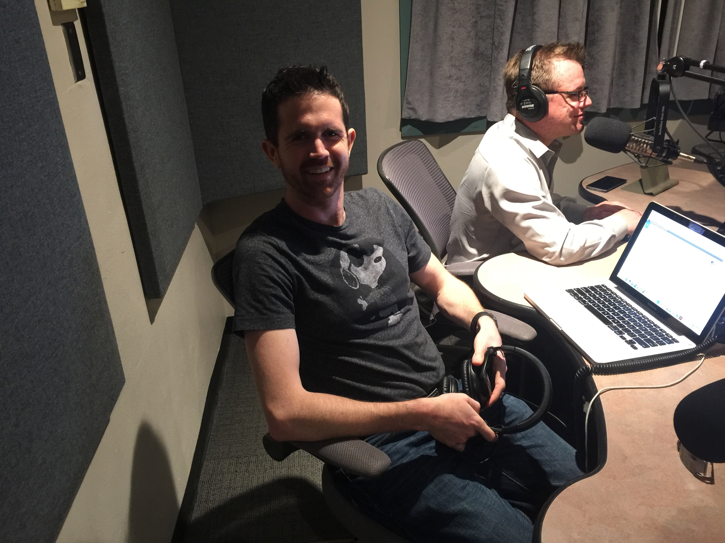
Tel (505)289-7678  jalilaarthur@kunm.org |  |  | Tel (505)252-5788  seth.brewer2@gmail.com |  |  | Tel (505)710-3717  gabehesch@gmail.com

Company Information
KUNM-FM
Oñate Hall 3rd floor, 303 Girard Blvd NE, Albuquerque, NM 87106
Tel (505) 277-4806
KUNM.org
